Hi all – a quick update from Community Pharmacy Shropshire – previously known as your LPC!

Independent Prescriber Training – Support with identifying a Designated Prescribing Practitioner (DPP)
James Milner (Community Pharmacy Clinical Lead from STW ICB) has secured a commitment from the Primary Care Training Hub to support community pharmacists wanting to undertake Independent Prescriber training to find a Designated Prescribing Practitioner prior to applying to a training provider. Whilst there will be limited opportunities to access this support, we are asking for any community pharmacist (employed or locum) looking to undertake NHS-funded IP training in the coming months to complete an Expression of Interest form at: https://forms.office.com/e/pWBgaRUgi1 or scan the QR code below.

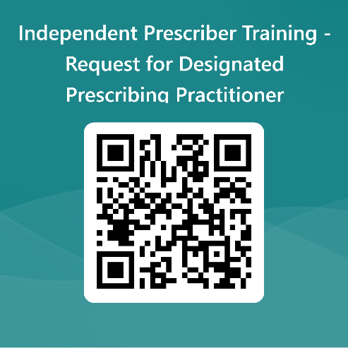

Smoking Cessation Service – Pharmacy Engagement Webinar 7/11/2023
Royal Wolverhampton Trust have been actively referring patients into the Smoking Cessation Service across the Black Country and beyond (including Shropshire) for some months, and are now holding a Pharmacy Engagement Webinar on Tuesday 7th November 2023 at 7pm – all contractors providing the SCS (or intending to do so) are welcome to attend, please register HERE.

Antibiotic Amnesty Campaign 2023
Contractors will have received an message via PharmOutcomes from Conor Jamieson (Antimicrobial Resistance Lead) and the NHSE Regional Team about the above campaign, which runs from 1st-30th November 2023 – please see the attached letter which details the campaign. We hope that our contractors will be able to take part, please use the Expression of Interest form on PharmOutcomes to register – do so by 15th October to receive free printed resources to support the campaign.

Workforce planning
Your LPC is working with colleagues across the ICB to identify how all sectors of pharmacy can attract and retain pharmacy professionals and support staff in Shropshire, Telford & Wrekin. Whilst secondary care and community trusts have strong representation and engagement in our workforce planning group, we are looking to recruit a few community pharmacy contractors who can provide the benefit of their experience in this field – if you would be able to help in this regard please email me with your details peter.prokopa@nhs.net

Extended Care Service – 7-day follow-up reminder
We have learnt from NHSE regional team that a significant number of pharmacies are NOT completing the 7-day follow-up on PharmOutcomes – if you don’t complete this module for every patient you have seen under the service then you won’t be paid the service fee or reimbursed for medicines supplied. If you are unable to make contact with the patient after three attempts at different times/days, then this can be marked as lost to contact and payment will be generated.

Telford STaRS update
I met with Michelle Astbury, the Clinical Lead for Telford STaRS programme to discuss the current situation with Substance Misuse Services in Telford & Wrekin. Whilst the service provided by most contractors is good, there were a few concerns raised:
- Many contractors are finding it difficult to accept new clients for Opiate Substitution Therapy (OST - methadone & buprenorphine) Observed Consumption, meaning some clients are having to travel significant distances to be able to access the service. We would ask all contractors currently registered with Telford STaRS to review their capacity and contact the team if you are able to accept more clients.
- Temporary closures and Business Continuity – please ensure that all members of your team are aware of business continuity plans in case a temporary closure means services to Observed Consumption clients are interrupted; this isn’t simply a default to refer back to STaRS for a new prescription, but may mean working with colleagues locally to enable collection at other pharmacies (where an FP10MDA prescription has not yet been commenced) or whether other pharmacies within the same group might support temporary pharmacist cover to allow OST client collections. Note that when a client is referred back to STaRS for a new prescription, there may not be a prescriber available at that time.
- Green FP10 prescriptions for disulfiram and acamprosate – StaRS also have a number alcohol abuse clients who are prescribed these items on green FP10s, usually for 28 days’ treatment; these prescriptions should be treated in the same way as any other EPS or paper prescription, and the medication dispensed to the patient with “reasonable promptness” as per Terms of Service. Unlike OST clients receiving medication via blue FP10MDA prescriptions, there is no option to only dispense with prior agreement between STaRS, patient and pharmacy. If the item is unavailable, please support clients in trying to source from alternative pharmacies, as you would with any other medication – please do not refer back to STaRS unless there is no alternative.
- Where changes of opening hours are being planned, please ensure OST clients are provided with full information, and liase with STaRS to ensure their records are accurate in terms of pharmacy opening hours.

Pharmacy Services
Your LPC continues to work with stakeholders across the ICS to maximise the uptake of pharmacy services – particular focus currently is on Smoking Cessation Service (SCS), Discharge Medicines Service (DMS), Oral Contraception Service (OCS), Hypertension Case Finding Service and Community Pharmacist Consultation Service (CPCS).

Stephanie Green continues engagement with both GP practices and pharmacies to support all parties in service implementation and delivery – if you need support on service-related matters don’t hesitate to contact Stephanie (as cc’d). We are also pleased to announce that Amanda Alamanos has joined CP Shropshire on a temporary contract as Community Pharmacy Integration & Support Officer. Amanda may well be known to many of you through previous roles in primary care for NHSE Area Team (and previously with the PCT), and since leaving her last role with NHS England in the National Diabetes Programme has also been working in a Services role with Derbyshire LPC. Amanda will be focussing on supporting me with commissioner engagement on community pharmacy services, and supporting Stephanie at pharmacy and practice level.

Smoking Cessation – referrals from Shrewsbury and Telford Hospitals continue to increase steadily, and the smoking team at SaTH are looking to ensure referrals are being made to pharmacy contractors who are able to accept those and follow up in delivering motivational support to referred patients as per the Advanced Service Specification. Please ensure that if you are registered to provide the service that you have the advisors in place ready to accept referrals; if that is not the case, and not likely to be resolved within a short space of time please de-register via MYS. Don’t forget, referrals can come from trusts outside of STW – for example, a significant number are being made by Royal Wolverhampton Trust – see the information above on their SCS Webinar on 7th November.

Discharge Medicines Service – please ensure that regular checks are made on PharmOutcomes to pick up DMS referrals; there have been a few incidences of contractors failing to act on referrals within the specified timescales ( 3 days). DMS is an ESSENTIAL SERVICE – failure to provide (or attempt to provide) the service MAY be considered a breach of Terms of Service, and put contractor income at risk. Furthermore, please ensure data is entered from PharmOutcomes into MYS to claim for DMS service delivery.

GP referral to CPCS – we continue to work on increasing the number of practices making referrals to CPCS; again, please ensure that referrals are actioned promptly as per the Service Specification, and that patients are only referred back to GP practices where their clinical condition requires it. If referrals would also be relevant for Extended Care services such as UTI treatment, should you be unable to provide the Extended Care service (either due to not being registered to provide or without a pharmacist able to provide at that time) then onward referral to another pharmacy provider, rather than back to GP, is necessary.

Finally, your LPC meets next on Tuesday 24th October; don’t hesitate to get in touch if you would like to attend as a contractor observer at this or any future meeting.

Kind regards
Peter

